Empowering Students as Writers Through the Use of Effective Elaboration
Gaylynn Parker
gaylynn.parker@nebo.edu
November, 2016

*Feel free to use, refuse, or change it up to make it fit you and your classroom.

**Email me if you want a zip drive of the powerpoint and handouts.

Five PARTS (not paragraphs) of Effective Writing
www.learnnc.org
1. Focus:
- address the prompt directly
- decide your point of view: thesis (informational) or claim (argument); narrow your topic
- decide what you are really thinking then revise to get rid of “I think” and “In my opinion” statements
- significance (why is this important?); make it matter to you and your audience
2. Organization (Structure):
- use an organization that fits the topic (compare/contrast, problem/solution, argument, etc.)
- use the format given (essay, letter, proposal, etc.)
- consider your purpose and audience in determining the structure
- use the number of paragraphs needed to address the prompt

Introduction: hook/background/thesis or claim
Body: topic sentence/reason (for argument), introduce the quote, give the quote, explain the quote (evidence and elaboration)
Counter Argument and Concession (for argument): what does the opponent say and what is your argument against their reason
Conclusion: restate claim/thesis; summarize reasons; overall significance; final statement
Transitions: words, phrases, and sentences throughout the essay to move from one topic to the next)
3. Support and Elaboration: this is the bulk of your essay
- logical reasoning and relevant evidence that is sufficient (enough) and credible (believable)
- introduce the expert and cite the source
- give the reason and support with evidence and elaboration
Some Types of Elaboration:

- explanation
- analysis
- figurative language
- relationships
- examples
- implications

4. Style: control of language that is appropriate to purpose, audience, and context of the writing task. Style is evident through
- Sentence Fluency: sentence type, length, and varied beginnings; smooth and natural sounding rather than awkward, stilted, and contrived.
- Word Choice: accurate (connotation/denotation), varied, and vivid; strong nouns and action verbs; avoid overused, wordiness, and redundancy
- Tone: appropriate for purpose and audience (formal vs. informal) *see handout below
5. Conventions:
- mechanics (punctuation, capitalization, spelling)
- usage (correct use of words—verb tense, subject/verb agreement, paragraph formation)
- grammar (correct placement of words)
- sentence formation (appropriate sentence types for purpose)
Remember:
- It’s not about the number of paragraphs, it’s about what you have to say/the point you are trying to make. Find a way to make the text matter and then write with authority! You have to engage! If you want this topic to matter to your audience, it has to matter to you.
- It’s not about length, either. It’s about finding a balance between not saying enough and saying too much. DON’T repeat yourself just to meet the length requirement!
- It’s not about a formula. It’s about thinking, evidence, purpose, and audience. It’s about being free to think for yourself.
- Think of connections to other texts and to the world; think of similar themes and topics and make connections.

Say what you want to say using the necessary PARTS and attributes!

Parts  (what the students grade) | Attributes  (what the teacher grades)
Focus: Prompt is addressed directly; writer does not ramble or get off topic. | Style (Sentence Fluency): Sentence type, length, and varied beginnings; smooth and natural sounding rather than awkward, stilted, and contrived.
Organization: Clear introduction, body, and conclusion with clear transitions throughout. | Style (Word Choice): Accurate, varied, and vivid; strong nouns and action verbs; avoid overused, wordiness, and redundancy
*Support and Elaboration: quotes are credible, relevant, accurate, and sufficient; quotes are cited correctly; elaboration shows students’ comprehension of the topic through correct interpretation of evidence (quotes); quotes and elaboration directly support thesis/claim. | Conventions: Punctuation, capitalization, spelling, usage (correct use of words), and grammar (placement of words).
Transitions: Effective use of words, phrases, and sentences to move from one idea to the next. | Tone: Either formal or informal, determined by purpose and audience including use of slang words, conversational tone, and objective point of view, etc.

Multi-Paragraph Informational Essay
Color-Coding
Color-coding your essay helps you make sure all the PARTS are in place.

First Paragraph (Introduction):
- Hook (grab the reader’s attention): ORANGE
- Background Information (explain the context/NOT a summary): BROWN
- Definition (optional): PINK
- Thesis (what the essay is about): UNDERLINE & BOLD
- Source (the author/article title): BLACK (parentheses)
Body Paragraphs (Support and Elaboration):
- Transition (move from one idea to the next): CIRCLE or italics
- Topic Sentence (what the paragraph is about): UNDERLINE
- Introduce the Evidence (source): RED
- Evidence/Quote/Paraphrase (Really? Prove it to me.): GREEN
- Elaboration (I don’t get it. Explain the evidence to me.): BLUE
- Summarize/Transition: UNDERLINE/CIRCLE or italics
- Source (the author/article title): RED (parenthesis)
Last Paragraph (Conclusion):
- Transition (move from one idea to the next): CIRCLE or italics
- Summarize Key Points/Restate Thesis: UNDERLINE & BOLD
- Overall Significance (why is this issue/topic important?): BROWN
- Closure (return to hook): ORANGE
- Source (the author/article title): RED (parenthesis)

ALL PARAGRAPHS SHOULD CITE YOUR SOURCE WHETHER YOU PARAPHRASE, SUMMARIZE OR QUOTE!

The majority of your essay should be BLUE (elaboration)! The elaboration is when you explain the support/evidence in your own words.

The next biggest color should be BROWN. This shows that you understand the issue and its importance.

Multi-Paragraph Argument Essay
Color-Coding
Color-coding your essay helps you make sure all the PARTS are in place.

First Paragraph (Introduction):
- Hook (grab the reader’s attention): ORANGE
- Background Information (explain the context/NOT a summary): BROWN
- Definition (optional): PINK
- CLAIM (the point you want your reader to accept): UNDERLINE & BOLD
- Source (the author/article title): RED (parentheses)
Body Paragraphs (Support and Elaboration):
- Transition (move from one idea to the next): CIRCLE or italics
- Topic Sentence (your first reason to support your claim): UNDERLINE
- Introduce the Evidence (source): RED
- Evidence/Quote/Paraphrase (Really? Prove it to me.): GREEN
- Elaboration/Reasoning (explain how the evidence supports the claim): BLUE
- Summarize/Transition: UNDERLINE/CIRCLE or italics
- Source (the author/article title): RED (parenthesis)
Concession Paragraph:
- Transition (move from one idea to the next): CIRCLE or italics
- Topic Sentence (the other side’s claim/opposing claim) = UNDERLINE
- Concession (a statement to acknowledge the opposing claim is valid) = PURPLE
- Turn Back (explain how argument is still valid despite this weakness) = GREY
Last Paragraph (Conclusion):
- Transition (move from one idea to the next): CIRCLE or italics
- Summarize Reasons/Restate Claim: UNDERLINE & BOLD
- Overall Significance (why is this issue/topic important?): BROWN
- Closure (return to hook): ORANGE
- Source (the author/article title): RED (parenthesis)
- Final Statement (a final appeal to the audience to convince the reader = BOLD

The majority of your essay should be BLUE (elaboration)! The elaboration is when you explain the support/evidence in your own words.

The next biggest color should be BROWN. This shows that you understand the issue and its importance.

Literary Analysis
Color-Coding
Color-coding your essay helps you make sure all the PARTS are in place.

First Paragraph (Introduction):
- Hook (grab the reader’s attention): ORANGE
- Short Summary or Background Information (plus name of novel/author): BROWN
- Definition (optional): PINK
- Thesis (purpose statement specific to the literary element assigned/addressed): UNDERLINE & BOLD
Body Paragraphs (Support and Elaboration): x three
- Transition (move from one idea to the next): CIRCLE or italics
- Topic Sentence (what the paragraph is about): UNDERLINE
- Introduce the Evidence (source): RED
- Support/Evidence/Quote/Paraphrase (example from the novel of literary element): GREEN
- Elaboration (explain how example from the novel shows literary element): BLUE
- Summarize/Transition: UNDERLINE/CIRCLE or italics
Last Paragraph (Conclusion):
- Transition (move from one idea to the next): CIRCLE or italics
- Summarize Thesis: UNDERLINE and BOLD
- Analysis and Application: BROWN
- Closure (return to hook/theme): ORANGE
The majority of your essay should be BLUE (elaboration)! The elaboration is when you explain the support/evidence in your own words.
The next biggest color should be BROWN. This shows that you understand the issue and its application.

fjdifd
difjdf
dkfjdkfmdfjsd oel fjsldifj odilfj lsdiljv lodsilfjvl asdiljodiflj odifljg dkfjdkfmdf oildjodfil jgosdflijg osdiflgj odfilkjgosdifljg ;osdiflkjgo;difl kjdofilmg dj flkgj dlkjg s;drlfgj ;odlfg m;sdflgj sodrfjg ;oldf dfkg dfligj dfoig dfoijg modfilgjodfi jodiflj goidfljgmodfi lmgdfoil mgodiflmg odfilmgodif mgdofim godifmgoidfmg oifdmgdofimg oidfmgoifdmg oidfmgdmofi flgm fog fmg pfmgfdpm gifdmg kdfmg kdfmg oifkdmg lkdfjg sodfljg modfiljgm aoweil irkfperofjbgvnm jdig mfdoim
xlix ejfesr;odgbmlcivkn
dkfjdkfmdfjsd oel fjsldifj odilfj lsdiljv lodsilfjvl asdiljodiflj odifljg oildjodfil jgosdflijg osdiflgj odfilkjgosdifljg ;osdiflkjgo;difl kjdofilmg dj flkgj dlkjg s;drlfgj ;odlfg m;sdflgj sodrfjg ;oldfjg sodfljg modfiljgm aoweil irkfperofjbgvnm xlixejfesr;odgbmlcivkn eilf joe;iari[qw-3ero werigjbm;xflcbm dj oidflvjoi dljodfilj idfljg ldfjg idflgjldfgj ldfgj dfpe94eirapeodfgmb;ldfx.dfk pd;ogjod;silkgpesor;dgk s;dlfk bmlf.kcmbvp’sx/dkfperldfmb lkgcvmb;ldf.xcvmpe;rsdlkg ldfk.cv
dkfjdkfmdfjsd oel fjsldifj odilfj lsdiljv lodsilfjvl asdiljodiflj odifljg oildjodfil jgosdflijg osdiflgj odfilkjgosdifljg odfilkjgosdifljg dj flkgj dlkjg s;drlfgj ;odlfg m;sdflgj sodrfjg ;oldfjg sodfljg modfiljgm aoweil irkfperofjbgvnm xlixejfesr;odgbmlcivkn (fdifei mvkmf dimf idmf ir ff) do jo;rsldjf odrilgj odlfikvj ;odsrilfgj vodfilvj dsro;fg m;oridlfjv ;osdfilkgj ;osdrilfgj ;oeridslfk d jdoirgj dorifg jsdorifgj odfig oidflgjodfigj oidfjg odfigj odifjg oidfjg oifdjgoid odifjg oidfjg oifdjgoid fjoidsflg jodsfilgjosdfil jgoidfljg oidfljgo idfljgodif jgodifj godifljgoi dfljgdosfil gjbdfoi gjdofiljg odifljgoidlfj gmodfiljg odifljgo dfljgodlj dfoigjdfio joidljg odsfiljdfoig ljoidrs
dkfjdkfmdfjsd oel fjsldifj odilfj lsdiljv lodsilfjvl asdiljodiflj odifljg oildjodfil jgosdflijg osdiflgj odfilkjgosdifljg ;osdiflkjgo;difl kjdofilmg dj flkgj dlkjg s;drlfgj ;odlfg m;sdflgj sodrfjg ;oldfjg sodfljg modfiljgm aoweil irkfperofjbgvnm xlixejfesr;odgbmlcivkn fdlkm;odifl jv ;oaeril eitr df pordijf dfoig odfigm dfoimg oidfmg odfimg oifhmiot mgrspomfgkldfm glbkgmfhoielmrglkdfbmm flkgmpeo srlkdgmlkdfmbgfolnjpsorldkgfmodlfbm fkg dflgm ldfkgm ldfkgm lfdkmglfkd glgknfdl flgbj flgbj odflgmb oifhmiot mgrspomfgkldfm glbkgmfhoielmrglkdfbmm flkgmpeo srlkdgmlkdfmbgfolnjpsorldkgfmodlfbm fkg dflgm ldfkgm ldfkgm lfdkmglfkd glgknfdl flgbj flgbj odflgmb fgolbm fgmlb fnujnjn
dkfjdkfmdfjsd oel fjsldifj odilfj lsdiljv lodsilfjvl asdiljodiflj odifljg oildjodfil jgosdflijg osdiflgj odfilkjgosdiflj fdkgj dfolgm dlfkgm ldfkgm ldkf mglkdf mglkdsfmg lkdfmglkfdg g ;osdiflkjgo;difl kjdofilmg dj flkgj dlkjg s;drlfgj ;odlfg m;sdflgj sodrfjg ; lkdfmglkfdg g ;osdiflkjgo;difl kjdofilmg dj flkgj dlkjg s;drlfgj ;odlfg m;sdflgj sodrfjg oldfjg sodfljg modfiljgm aoweil irkfperofjbgvnm xlixejfesr;odgbmlcivkn dk jdoifj diofj odisf dosifgd ofimgsdofig mdofismgdofi gmdofilgn oisl4jtroidfbmdofig moserigmsdfolib moiflbmdsof
Style in Formal Writing
A writer’s style is what sets his or her writing apart and makes it unique. Style is the way writing is dressed up (or down) to fit the specific context, purpose, or audience. Word choice, sentence fluency, and tone all contribute to the style of a piece of writing. Style is all about how a writer chooses words and structures sentences to achieve a certain effect.

- Sentence Fluency describes the sound or flow of a piece of writing and how sentences are used to enhance meaning.
- Varied Sentence Types (simple, compound, complex, compound/ complex)
- Varied Sentence Length (short, medium, long)
- Varied Sentence Beginnings (sentences should have different beginning words; sentences should not begin with a pronoun unless the antecedent is clear)
- Smooth and Natural Sounding, not Awkward (read your sentences out loud to make sure they are smooth and natural sounding)
- Transitions (transitions help your writing flow from one idea to the next instead of sounding choppy/jumping from one idea to the next)
- Sentence Combining (commas in a series; varied sentence types)

- Word Choice is more than the correct use of words. A good writer selects words that are accurate in the context AND that communicate ideas elegantly and powerfully.
- Accurate (connotation vs. denotation)
- Avoid Overused Words (nice, good, bad, important, etc.)
- Redundancy & Wordiness (be concise by getting rid of unnecessary filler words or strings of prepositional phrases, etc.)
- Varied and Vivid Word Choice (use a simile or metaphor instead of an overused adjective; choose unusual yet appropriate words)
- Strong Nouns and Verbs (instead of a string of adjectives or adverbs choose strong nouns and verbs)
- Poor: He got out of bed quickly and agilely.
- Better: He sprang out of bed.
- Poor: The shaggy dog was mine.
- Better: The Old English Collie belonged to me.
- Action Verbs instead of Linking Verbs
- Jerome was an A+ student.
- Jerome earned straight A’s at school.
- Thesaurus Warning (using inflated writing to impress the reader is not authentic writing and just sounds bad)
- Tone: Most essays require formal writing (not informal). You want your essay to sound knowledgeable with a somewhat serious tone without sounding stuffy or artificial (fake).

INFORMAL |  | FORMAL
Instead of | Example | Use | Example
Slang | “cool” “awesome” | Figurative Language | simile/metaphor/ personification, etc.
Idioms | “knock your socks off” | Unusual word choice | The result was unique and surprisingly creative.
Conversational | “gonna” “kinda” “yeah” “well” “um” “like” “so yeah” “duh” | DON’T USE CONVERSATIONAL tone
Abbreviated | ASAP FYI | Spell out words | As soon as possible/ for your information
Simple or Imprecise | “he got some stuff at the store” | Be detailed and exact | NAME specifics
Contractions | can't won’t didn’t | Separate the words | cannot will not did not
Subjective | In my opinion…  I think….  You really should… | Objective | Express your opinion as a fact
First or Second Person Point of View | How would you feel if you had been born during the Great Depression? | Objective point of view | Imagine living during the most devastating economic time period in history.
Clichés | Dance as if no one is watching. | Original phrases | Don’t be afraid to express yourself
Emoticons/Texting | LOL OMG | DON’T USE Emoticons or Texting language
(multiple) Exclamation Points | !!  !!??!! | Descriptive word choice/ Emotions should come through the words | Angel Island immigrants were treated like prisoners.
Simple Sentences | Angel Island treated immigrants well. Ellis Island treated immigrants poorly. | Combine sentences when appropriate | Angel Island treated immigrants well, but Ellis Island treated immigrants poorly.
Hyperbole | “Since the beginning of time” “A wise man once said” | Accuracy/Name source | Einstein once said, “……
Addressing the Audience Directly | “This essay will talk about” “In this essay you will learn”  “I hope you liked this essay” | Just STATE the topic sentence. | Although Angel and Ellis Islands were similar in many ways, they were also very different.

Editing Checklist
 | Checklist Items
 | I read my essay slowly OUT LOUD multiple times to catch my own mistakes.
Capitalization | I capitalized the first word of every sentence.
 | I capitalized all proper nouns.
 | I did not capitalize random words in sentences.
Punctuation | Each sentence I wrote ends with a period, a question mark, or an exclamation point.
 | I did not use more than one exclamation point or a combination of end sentence punctuation (!!!!!? etc.).
 | I used punctuation correctly (semicolons, parentheses, apostrophes, quotation marks, etc.).
 | I used commas in a series correctly.
 | I used commas and semicolons in compound sentences correctly.
 | I used a commas in complex and compound/complex sentences correctly.
 | I used a comma after an introductory phrase.
Paragraphs | I indented the beginning of each new paragraph.
 | My paragraphs are more than one sentence (not rambling).
Grammar | Each of my sentences is a complete thought with a subject and a verb.
 | There are no comma splices, fragments, or run-ons.
 | My sentences do not begin with a coordinating conjunction (FANBOYS).
 | I checked multiple times to see if I used conjunctions (and, but, so, then) too often. I got rid of excess conjunctions and divided rambling sentences into multiple sentences.
 | Subjects and verbs agree in number (singular subject = singular verb; plural subject = plural verb).
 | When I use pronouns, the antecedent is clear.
 | I use verb tenses consistently (past, present future).
Spelling | I spelled all words correctly including confusing words (they’re, their, there, your, you’re, its, it’s, etc.).
Style Checklist
 | Checklist Items
 | I read my essay slowly OUT LOUD multiple times to catch my own mistakes.
Sentence Fluency | I used various sentence types (simple, compound, complex, compound/complex).
 | I wrote with varied sentence lengths (short, medium, long).
 | I varied the beginnings of my sentences.
 | I did not begin a sentence with a coordinating conjunction.
 | I combined sentences when it would improve readability, sound, and flow.
 | My sentences sound smooth and natural, not awkward.
Word Choice | I used appropriate words to accurately convey meaning.
 | I avoided vague, overused words and clichés.
 | I cut out any unnecessary words. Nothing is more complicated than it needs to be.
 | I chose clear interesting, colorful, precise words and made sure that they were appropriate for my audience.
 | I used similes, metaphors, and personification where appropriate to accurately convey meaning.
 | I used strong nouns and verbs instead of strings of adjectives and adverbs.
Tone | I avoided using slang, idioms, conversational, and abbreviated (ASAP, FYI) language.
 | I tried not to use contractions.
 | My language is detailed and exact rather than simple and imprecise.
 | I used an objective point of view.
 | I did not use emoticons or texting lingo.
 | I did not address the audience directly.
 | My language is formal and academic in tone without sounding pretentious and inflated.

Teacher Guide Sheet To Teaching Effective Elaboration
http://slideplayer.com/slide/10057728/
Fact (Evidence): This is a QUOTE from the source (or paraphrase).
Source (Title of Article/Author): What is the source?
Elaboration (Anticipate the needs of the audience, supply necessary information, context or explanation): *Daron Kennett
Examples: missing background knowledge; misunderstanding; bias; preconceived ideas
- Offer Explanations
- Greater Depth
- Alternate Language
- Sequence

- Provide Analysis
- Examine the Parts or Components
- Show how they Relate or Work Together
- Description

- Use Figurative Language
- Simile
- Metaphor
- Analogy
- Description/Compare and Contrast

- Show Relationships
- Hierarchy
- Compare/contrast

- Give Examples
- Concrete
- Abstract
- Multiple/Alternate Contexts

- Identify Implications
- Extrapolate—extend the application to an unknown situation by assuming that existing trends will continue or similar methods will be applicable.
- Interpolate—introduce something additional or extraneous between other things or parts
Transitions: Use words or phrases to move smoothly to the next idea.

Elaboration
Fact (Evidence):

Source (Title of Article/Author):

Elaboration (Interpret the information):

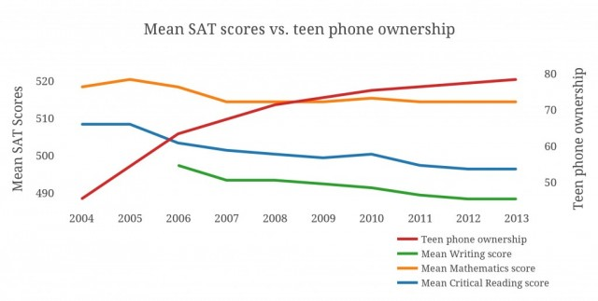

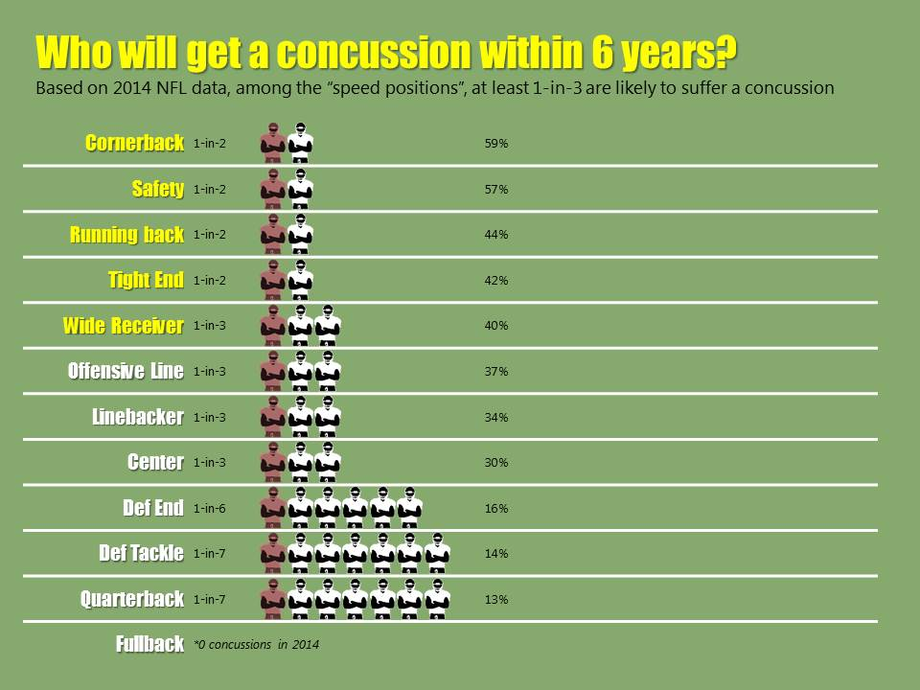

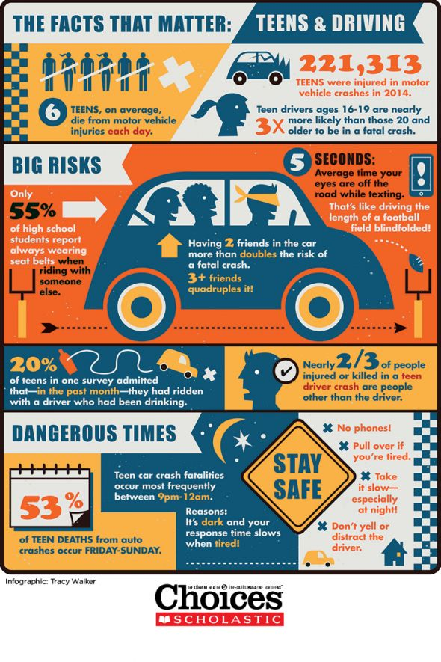
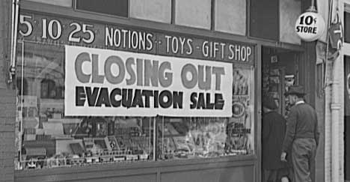

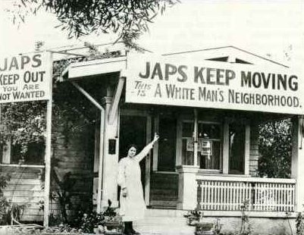

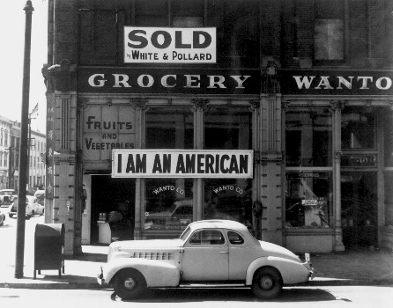

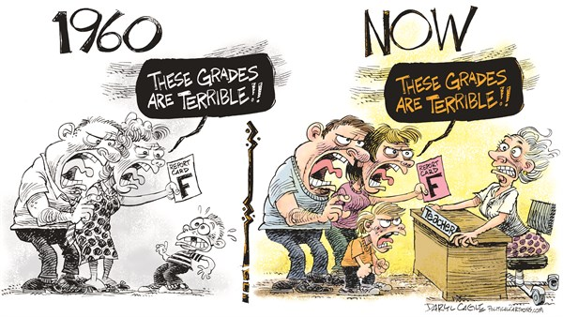
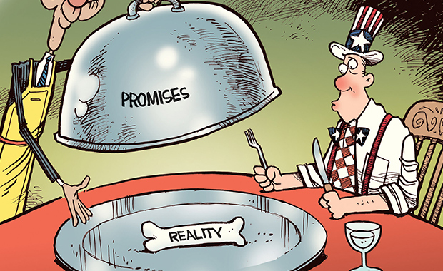

1963: I HAVE A DREAM (Martin Luther King, Jr.)
In his iconic speech at the Lincoln Memorial for the 1963 March on Washington for Jobs and Freedom, King urged America to “make real the promises of democracy.” King synthesized portions of his earlier speeches to capture both the necessity for change and the potential for hope in American society.

“Let us not seek to satisfy our thirst for freedom by drinking from the cup of bitterness and hatred. We must forever conduct our struggle on the high plane of dignity and discipline. We must not allow our creative protest to degenerate into physical violence. Again and again, we must rise to the majestic heights of meeting physical force with soul force. The marvelous new militancy which has engulfed the Negro community must not lead us to a distrust of all white people, for many of our white brothers, as evidenced by their presence here today, have come to realize that their destiny is tied up with our destiny, and they have come to realize that their freedom is inextricably bound to our freedom. We cannot walk alone.”

1965: WE SHALL OVERCOME (Lyndon B. Johnson)
On March 7th, marchers trying to get from Selma to Montgomery meet Alabama state troopers in a confrontation that becomes known as “Bloody Sunday.” That day results in a larger four-day march involving Martin Luther King, and a powerful speech by President Lyndon Johnson calling for the passage of the Voting Rights Act.

“Rarely in any time does an issue lay bare the secret heart of America itself. Rarely are we met with a challenge, not to our growth or abundance, or our welfare or our security, but rather to the values and the purposes and the meaning of our beloved nation. The issue of equal rights for American Negroes is such an issue. And should we defeat every enemy, and should we double our wealth and conquer the stars, and still be unequal to this issue, then we will have failed as a people and as a nation. For, with a country as with a person, “what is a man profited if he shall gain the whole world, and lose his own soul?” There is no Negro problem. There is no Southern problem. There is no Northern problem. There is only an American problem. And we are met here tonight as Americans--not as Democrats or Republicans; we're met here as Americans to solve that problem.”

